Tornament Winner (Easy)

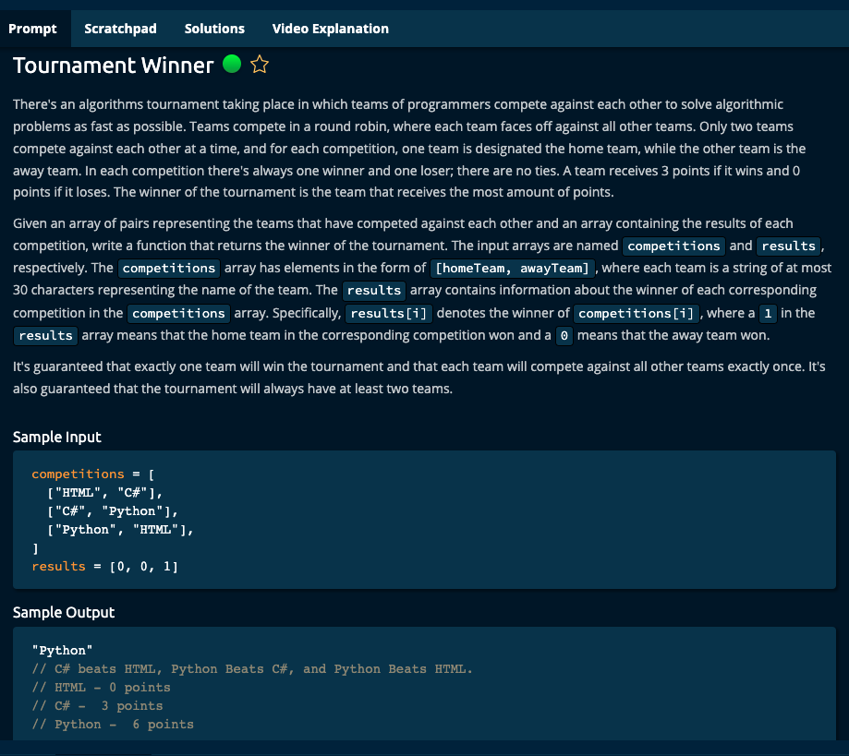

Solution 1: O(n) Time | O(k) space

def tournamentWinner(competitions, results):

team_score_dict = {}

n = len(results)

for i in range(n):

if results[i] == 0:

if competitions[i][0] not in team_score_dict.keys():

team_score_dict[competitions[i][0]]= 0

if competitions[i][1] not in team_score_dict.keys():

team_score_dict[competitions[i][1]] = 1

else:

team_score_dict[competitions[i][1]] += 1

else:

if competitions[i][0] not in team_score_dict.keys():

team_score_dict[competitions[i][0]]= 1

else:

team_score_dict[competitions[i][0]] += 1

if competitions[i][1] not in team_score_dict.keys():

team_score_dict[competitions[i][1]] = 0

max_score = max(team_score_dict.values())

winner = []

for k in team_score_dict.keys():

if team_score_dict[k] == max_score:

return k

Solution 2: O(n) Time | O(k) space

def tournamentWinner(competitions, results):

team_score_dict = {}

n = len(results)

for i in range(n):

if results[i] == 0:

if competitions[i][1] not in team_score_dict.keys():

team_score_dict[competitions[i][1]] = 3

else:

team_score_dict[competitions[i][1]] += 3

else:

if competitions[i][0] not in team_score_dict.keys():

team_score_dict[competitions[i][0]]= 3

else:

team_score_dict[competitions[i][0]] += 3

best_team = [k for k, v in team_score_dict.items() if v == max(team_score_dict.values())]

return best_team[0]

Algoexpert Solution: O(n) Time | O(k) space

HOME_TEAM_WON = 1

def tournamentWinner(competitions, results):

currentBestTeam = ""

scores = {currentBestTeam: 0}

points = 3

for idx, competition in enumerate(competitions):

result = results[idx]

homeTeam, awayTeam = competition

winningTeam = homeTeam if result == HOME_TEAM_WON else awayTeam

updateScore(winningTeam, points, scores)

if scores[winningTeam] > scores[currentBestTeam]:

currentBestTeam = winningTeam

return currentBestTeam

def updateScore(winningTeam, points, scores):

if winningTeam in scores:

scores[winningTeam] += points

else:

scores[winningTeam] = points